100-Day Entry Plan
Goals of the 100-Day Entry Plan
The Goals of the 100-Day Entry plan are:
  - To establish an atmosphere of trust with the community and school system personnel.
  - To forecast educational student needs for prepared graduates.
  - To assess the alignment of academic programs to student performance outcomes.
  - To monitor school system efforts toward equity and access to ensure high-quality programming for all students.
  - To establish a system of progress monitoring for organizational efficiencies.
  - To establish consistent and reliable communication practices to ensure organizational stability.
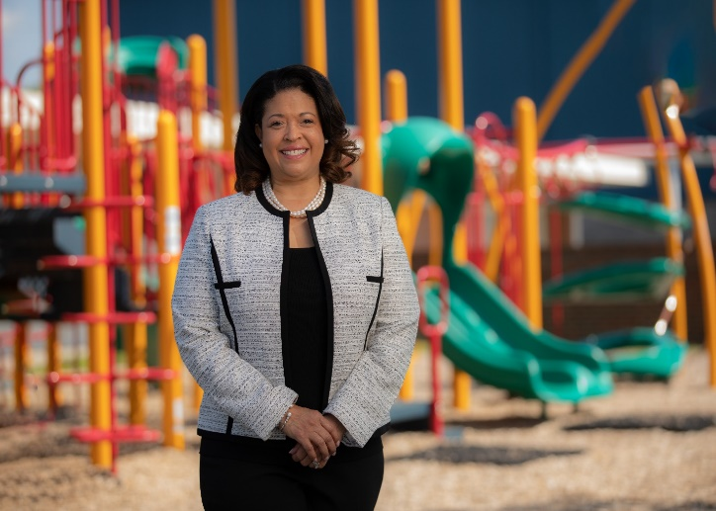
  - To ensure forward momentum for the school system in alignment with the direction of the Roanoke City School Board.

Destination 2030
Dramatic shifts in workforce expectations over the next decade require vision and strategic planning through the comparison of college and career readiness for:
  - The 2020 Graduate
vs.
  - The 2030 Graduate
Verletta White’s Entry Plan:
- Based on the exit plan for the 2030 graduate.
Why Is This Shift Important?
What The Research Says…
- “According to a recent Oxford report, 47 percent of today’s jobs will disappear, largely due to machine automation.” (www.quantumrun.com/macro-prediction/automation-new-outsourcing-future-work-p5).
- “Today’s educational system is simply not producing enough STEM (Science, Technology, Engineering, Math) graduates and tradespeople to match market needs…” (www.quantumrun.com/macro-prediction/automation-new-outsourcing-future-work-p5).

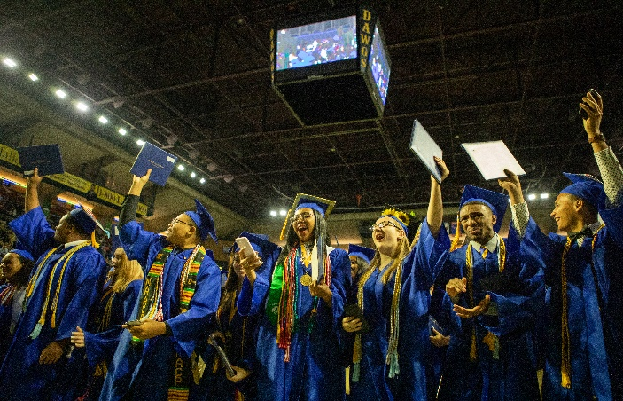

VW’s Approach: A Forward-Thinking Roadmap to:
- Prepare students for college, military, and the workforce, focused on S.T.E.A.M. (Science, Technology, Engineering, Arts, and Mathematics) instruction, with literacy integration, CTE (Career and Technology Education) and workforce development opportunities.
- Align human resources to course expectations for workforce demands.
- Provide students with optimal learning environments for post-graduation success.
- Establish soft skills and social-emotional supports for successful employability.
- Establish systems to evaluate equitable practices.
- Support teachers with a system direction in alignment with workforce demands.
- Establish health and safety procedures to prevent the spread of illnesses, such as COVID-19.

Superintendent’s 100 Day Entry Plan: Forward. Focused. Together.

Five Key Areas Based on Data, Research, and Feedback
  - Academic Accountability and Student Performance Measures
  - Equity and Access to High-Quality Instructional Programs
  - Operational Efficiency
  - Organizational Stability
  - Safety and Climate

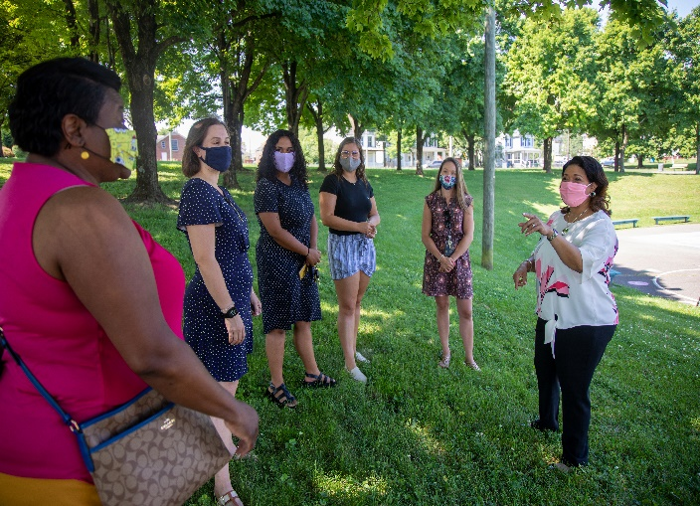

Academic Accountability and Student Performance Measures
In collaboration with the School Board, the superintendent will establish measurable key metrics to increase student achievement and close gaps in student performance by:
  - Establishing the Destination 2030 Vision Team, inclusive of school board members, teachers, students, and parents, to review the school system’s strategic plan.
  - Reviewing School Improvement Plan data to redirect professional development and central office support.
  - Meeting with central and school based personnel to begin the development of the FY22 budget, focusing on closing achievement gaps, literacy, and S.T.E.A.M.
  - Meeting with students and teachers to determine additional academic supports needed for increased student performance.
  - Collaborating with community college and local university leadership teams to assess readiness for P-TECH and industry initiatives.
  - Coordinating with the Economic and Workforce Development agency to connect CTE (Career and Technology Education) initiatives to the Destination 2030 vision and directly to local business opportunities to strengthen the economic viability of the region.
  - Meeting with all district leaders to receive a report on data dashboard updates and developments.

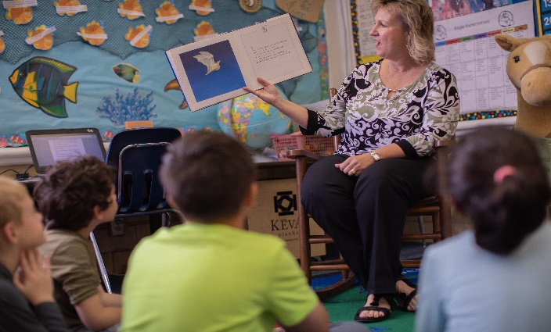

Equity and Access to High-Quality Instructional Programs
  - Review the status of the school system’s equity policy and initiatives.
  - Review and evaluate the long-term CTE plan to identify areas of growth for greater accessibility by students.
  - Review and evaluate plans for magnet expansions to identify areas of growth for greater accessibility by students.
  - Review and discuss alternative education programs for program accessibility with key staff and students.
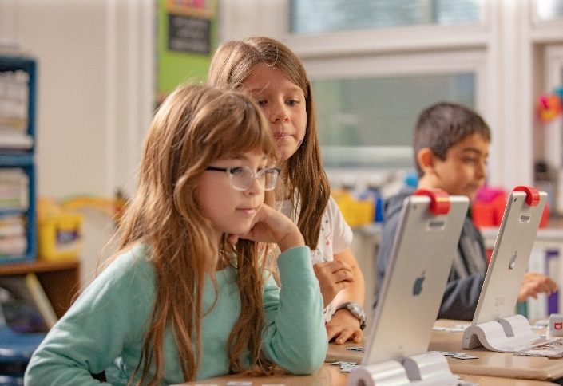

Operational Efficiency
  - Meet with teachers to determine alignment with Standards of Learning (SOLs), system priorities, and stakeholder feedback.
  - Meet with students and staff to observe instruction, discuss successes and challenges, gain insight on how to improve student performance.
  - Conduct a line-by-line review of the operating and capital budgets to identify cost savings and efficiencies for the FY22 operating budget.
  - Review outcomes of recent financial audits and initiate transition audit to determine where efficiencies are needed.

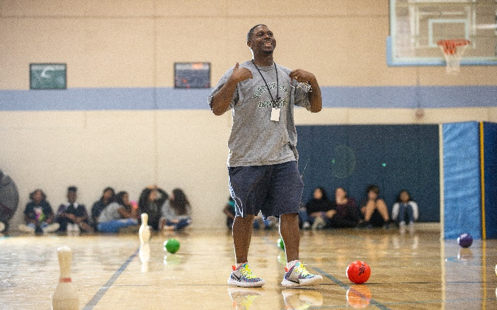

Organizational Stability
The superintendent will build trust with stakeholders by meeting with:
  - School board members to revisit system priorities, as permitted by Virginia law.
  - School board members at a school board retreat to establish common goals for school system improvements.
  - School based and central office leaders to establish and communicate the course and vision of the school system.
  - Parents, teachers, students, administrators, elected officials, and community members during Listening and Learning sessions to learn more about system challenges and to communicate the vision for stability.
  - Elected officials of Roanoke City to provide an update on school system initiatives and to determine priorities of the next legislative session.
  - Media outlets to communicate the school system’s direction and vision for enhanced communication and transparency.
  - Teachers and staff during professional learning sessions to monitor progress toward a shared understanding of the Standards of Learning, ESSA regulations, accreditation and graduation requirements, school safety and climate procedures.

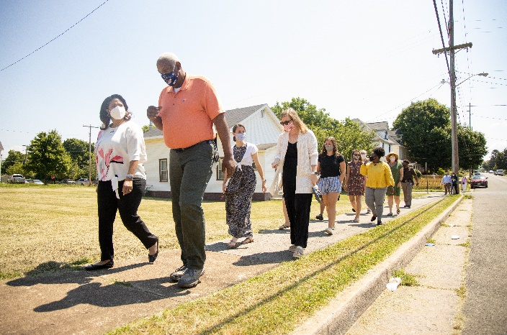

Safety and Climate
The superintendent will meet with:
- Transportation partners to discuss student behavior strategies, route planning, and performance outcomes.
- Parents and students to review the anti-bullying campaign for the 2020-21 school year.
- The Office of Special Education to discuss manifestation behaviors, support models for students and teachers, and parent involvement.
- Establish a Student Behavior and Discipline Council to specifically address prevention and restoration strategies, as well as logical consequences related to student behavior.

The superintendent will:
  - Establish a Social-Emotional Learning team to review data related to suspensions, dropout, suicide, and bullying to steer the course based on data and information.
  - Meet with students during school visits to discuss the quality of the instructional program (prevention), positive interventions (restoration), and discipline practices (logical consequences).
  - Establish and meet with the Superintendent’s Teacher, Principal, and Student Advisory teams to gain perspectives on system wide behavior initiatives.
  - In collaboration with health officials, establish a forward-thinking Health and Safety Task Force to review current health practices in schools/offices and to develop new health guidelines to prevent the spread of respiratory diseases for the safety of students and staff.

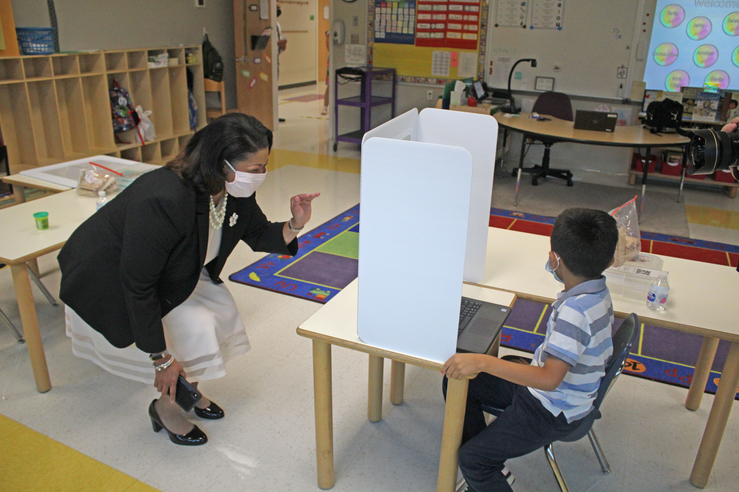

Destination 2030: Moving Forward, Staying Focused, and Working Together to Prepare Students for the World That Awaits Them

